**Effects of Interomone Ointments on Heart Rate and Behavior during Simulated Thunderstorm: Blind Ointment Study**

**John J. McGlone, Glenna Pirner**

**October 15, 2015**

**Executive Summary**

Thunderstorm-related fears are common in domestic dogs. As a thunderstorm approaches, fearful dogs typically respond with behaviors like hiding, pacing, or vocalizing. This study examined the effects of 2-methyl-2-butenal (2M2B), a maternal-neonatal pheromone found in rabbits, on heart rate and behavior before, during, and after a simulated thunderstorm in domestic canines. Results of this study are generally in agreement with those of the previous 2M2B ointment study (see report from 6 April 2015). Heart rate of dogs receiving 2M2B ointment was lower than that of dogs receiving CON ointment both in the “during” period and most of the “after” period. Five of the eight dogs exhibited a significant decrease in heart rate during the simulated thunderstorm, reiterating the concept that some individuals may experience a stronger physiological response than others to interomones. Behavior was not significantly different between treatments in this study. All 2M2B ointment studies will be combined and analyzed to allow further conclusions to be drawn.

**Methods and Materials**

**General**

All research was conducted after approval of the Texas Tech University Institutional Animal Care and Use Committee. Space, management, and care of dogs were consistent with the US Animal Welfare Act. Research was conducted at Texas Tech University. Dogs were obtained from a licensed facility and transported to Texas Tech University where they were individually housed in 1.22 m x 1.83 m kennels, with 2 kennels in each room. Food was provided once daily, and water was available ad libitum. A three day acclimation period allowed the dogs to rest and adjust to their new surroundings prior to testing.

Dogs (n = 4 males and 4 females) were mixed breeds, estimated to be between 3 and 8 years of age, and weighing 11.63 ± 5.1 kg at the beginning of the study. Table 1 provides a description of each individual dog. Dogs were selected from the facility’s population based on a high basal heart rate (> 100 bpm) and novelty to Texas Tech University. Two types of ointments were used, and researchers were blind to the test odor in each preparation. Ointments were labeled HWB51 and HWB52 in reference to internal delivery method identification methods. HWB51 was the control ointment (CON) with no interomone odor. HWB52 contained rabbit maternal pheromone (2M2B).

The simulated thunderstorm was a 15-minute track on the Sounds Scary! Dog training CD (Sound Therapy 4 Pets Ltd, Chester, England) played on a Fender Passport Event stereo system (Fender Musical Instruments Corp., Scottsdale, AZ). Bass, treble, and volume were adjusted so that the maximum sound level in each room was 96 db during the thunderstorm, with a baseline level of 69 db.

**Table 1.** Description of dogs used in this study.

|  |  |  |  |  |  |
| --- | --- | --- | --- | --- | --- |
| Dog | Age (yr) | Sex1 | Breed | Body weight (kg) | Behavior Score |
| Ariat | 4 | F | Hound X | 13.5 | 2.6 |
| Dewey | 3 | M | Terrier X | 8.3 | 2.3 |
| Dixie | 7 | F | Terrier X | 10.6 | 2.4 |
| Lola | 1 | F | Terrier X | 8.5 | 1.9 |
| Peanut | 7 | M | Jack Russell | 6.5 | 2.2 |
| Pepper | 5 | F | Heeler | 15.5 | 1.6 |
| Tank | 2 | M | Pit Bull | 21.7 | 2.3 |
| Wrangler | 1 | M | Chihuahua X | 8.4 | 2.9 |

1F = intact female; M = intact male

**Design**

This study was designed as a 2 by 2 Latin Square with two sexes and two treatments. All dogs received both CON and 2M2B ointments, in random order, so that the same dogs were compared for each treatment; each room was randomly assigned a treatment each day, with a 48-hour washout period between each set of trials. The ointment treatment (CON or 2M2B ointment) was applied at time zero in the During period or time 16 minutes from the start of data collection. Each trial consisted of a 15 minute period which served as the baseline (“before”), a 15 minute thunderstorm simulation (“during”), and a 15 minute recovery period (“after”). At the end of the “before” period a researcher massaged 1 mL of the assigned ointment onto the dorsal aspect of the dog’s nose. This period of time lasted an average of two minutes and was not included in the heart rate or behavior analyses. Immediately after administration of treatments the thunderstorm track was started. The “after” period began at the end of the 15 minute simulated thunderstorm. Figure 1 gives a timeline of periods and treatments.

**Figure 1.** Timeline of periods and treatment administration during each trial.

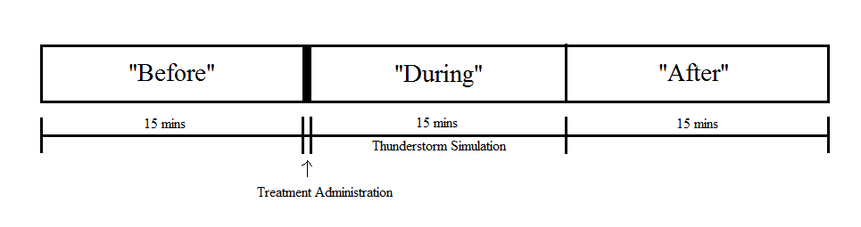

**Heart Rate**

Each dog was fitted with a Polar Pro heart rate monitor belt (Polar Electro, Lake Success, NY) and wore the belt one hour daily for three consecutive days prior to the trial to allow acclimation to the belt. Dogs wore the same heart rate monitor for every trial. Heart rate was recorded every one second throughout the trial and averaged in one minute periods. Determination of which values corresponded to trial periods was done by matching heart rate monitor times to those in the behavior videos.

**Behavior**

Camcorders (Panasonic HDC-TM90, Osaka, Japan) were used to record behaviors during the trial. Behaviors of interest included sitting, lying, standing, locomotion, and vocalization. Videos were viewed by researchers blind to the treatments in one minute scan samples. Sitting, lying, standing, or locomotion was tallied every 60 seconds during the trial and divided by 15 to give percent of time spent engaged in each behavior; vocalization was tallied as it occurred and therefore is reported as number of vocalizations observed.

**Data analyses**

Data were analyzed using the General Linear Models Procedure of SAS (SAS Inst., Inc., Cary, NC). The data were first analyzed to determine if sex had an effect; there was an effect of sex on heart rate but not on behavior, therefore sex was omitted from the behavior model. The heart rate model included interactions of treatment*time, treatment*sex, and used dog(treatment*sex) as an error term. The behavior model included interactions of treatment*period and used dog*treatment as an error term. Least Squares means were calculated and compared for both heart rate and behavior.

**Results and Discussion**

**Heart Rate**

Overall, the interaction of treatment*time was not significant; however, there were several individual time points that differed significantly between treatments. Generally, dogs receiving CON ointment had a higher heart rate than dogs receiving 2M2B ointment during the thunderstorm. Figure 2 shows the average heart rate per minute of dogs before, during, and after the simulated thunderstorm.

**Figure 2.** Average heart rate per minute before, during, and after a simulated thunderstorm of dogs experiencing control (CON) or rabbit maternal pheromone (2M2B) ointment. n = 8 dogs. SEp = 7.85.

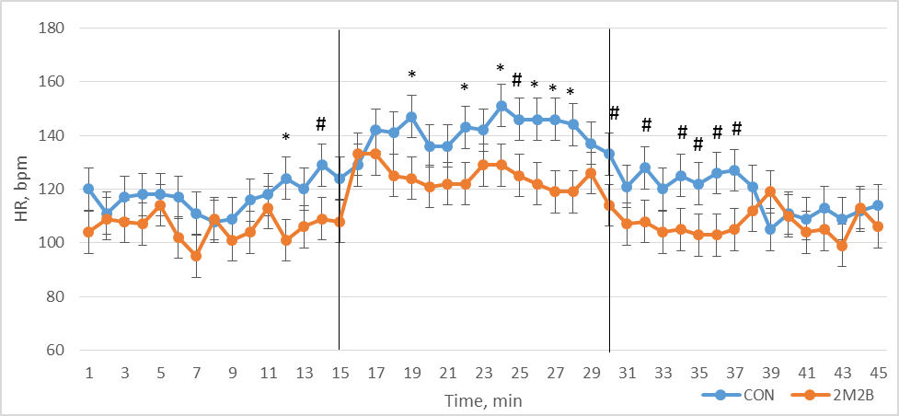

*Within a time point, means differ *P* < 0.05.

# Within a time point, means differ *P* < 0.1 – *P* > 0.05.

When heart rate was analyzed by period, a dog*treatment interaction became apparent. Of the eight dogs in this study, five had significantly lower heart rates during the simulated thunderstorm when treated with 2M2B ointment compared to when they were treated with CON ointment. These five dogs were termed “responders.” This is consistent with patterns observed in earlier studies, and supports the concept that some dogs may be more sensitive to and/or be more likely to elicit a physiological response to interomones. Heart rates comparisons between treatments in the “during” period are shown in Figure 3.

**Figure 3.** Heart rate of “responder” dogs receiving control (CON) or rabbit maternal pheromone (2M2B) ointment during a simulated thunderstorm. SEp = 4.02.

a

a

a

a

a

a

b

a

b

a

b

a

b

a

b

a

a,b Within each dog, means differ *P* < 0.05.

Heart rate by minute was analyzed for the five “responders.” Figure 4 shows the heart rate patterns of these dogs before, during, and after the simulated thunderstorm. Immediately after the thunderstorm began, the heart rate of dogs in both treatments increased; however, dogs’ heart rates returned to baseline approximately seven minutes later and remained at baseline for the rest of the trial when they were treated with 2M2B ointment. Heart rate of dogs treated with CON ointment did not return to baseline until near the end of the trial, approximately 25 minutes after application of the ointment. This suggests the rapid action of 2M2B to modify heart rate in dogs experiencing a stressful event.

**Figure 4.** Average heart rate per minute of “responder” dogs receiving control (CON) and rabbit maternal pheromone (2M2B) ointments before, during, and after a simulated thunderstorm. n = 5. SEp = 9.34 (SEp is the pooled standard error of the least squares mean).

During the thunderstorm, “responder” dogs experiencing 2M2B had an average heart rate that was 20.6% lower than dogs experiencing CON ointment. Figure 5 shows the heart rate for these five dogs in the “during” period.

**Figure 5.** Average heart rate by minute during a simulated thunderstorm for dogs determined to be “responders” to the treatments. n = 5 dogs; SEp = 8.86.

*Within a time point means differ *P* < 0.05.

#Within a time point means differ *P* < 0.1 – *P* > 0.05.

Regression analyses (Figure 6) comparing 2M2B to CON were conducted on the “during” period heart rate data from the five “responders”. Heart rate of dogs receiving CON ointment remained elevated at 140 ± 6 bpm throughout the “during” period, whereas the heart rate of dogs receiving 2M2B ointment decreased consistently over time from approximately 134 bpm to approximately 104 bpm.

**Figure 6.** Regression analyses comparing heart rate of “responders” receiving control (CON) ointment to those receiving rabbit maternal pheromone (2M2B) ointment during a simulated thunderstorm. N = 5 dogs.

**Behavior**

No difference in sitting, standing, lying down, or moving was observed in this study. One dog vocalized in all three periods of the CON trial but did not vocalize at any time throughout the 2M2B trial. Because of this, vocalizations in the “during” period were found to be significant; however, this is not consistent for all dogs and should be considered lightly in terms of an interomone effect. Table 2 gives the percentage of time dogs spent in each behavior on average during each period. Vocalizations are given as number of vocalizations rather than percent of time.

**Table 2.** Average percent of time dogs spent engaged in each behavior before, during, and after a simulated thunderstorm. N = 8 dogs. The “during” period is highlighted because this is the period in which one might expect differences.

|  |  |  |  |  |  |  |  |
| --- | --- | --- | --- | --- | --- | --- | --- |
| Treatment | Period | | Sit (%) | Lay (%) | Stand (%) | Move (%) | Vocalizations |
| CON | Before | 21.6 | | 47.5 | 10.9 | 20.0 | 0.1 |
| CON | During | 65.0 | | 25.8 | 1.7 | 7.5 | 1.4a |
| CON | After | 39.2 | | 41.7 | 14.1 | 5.0 | 0.25 |
| 2M2B | Before | 28.3 | | 40.0 | 15.0 | 16.7 | 0.0 |
| 2M2B | During | 46.7 | | 45.0 | 3.3 | 5.0 | 0.0b |
| 2M2B | After | 35.9 | | 60.0 | 3.3 | 0.8 | 0.0 |
| SEp | | 11.27 | | 13.00 | 5.27 | 6.80 | 0.42 |
| Treatment effect *P*-value | | 0.59 | | 0.35 | 0.70 | 0.55 | 0.10 |
| Treatment*Period *P*-Value | | 0.54 | | 0.51 | 0.33 | 0.99 | 0.29 |

a, b Within a time period, means differ *P* < 0.05

A Chi-square analysis was conducted to compare percentage of time spent sitting or lying in the “during” period to the “before” period for each treatment. When treated with CON ointment, dogs were more likely to sit during the simulated thunderstorm than before; however, when treated with 2M2B ointment, dogs increased lying behavior in the “during” period compared to “before” *X*2 (1, N = 1) = 8.20, *P* < 0.05.

**Conclusions**

As seen in previous studies, heart rate of dogs experiencing 2M2B ointment did not elevate as greatly as dogs experiencing CON ointment during a simulated thunderstorm. Heart rate of dogs experiencing 2M2B ointment returned to baseline within one minute after the end of the thunderstorm, whereas heart rate of dogs experiencing CON ointment did not return to baseline until approximately nine minutes after the simulated thunderstorm ended.

Also as in previous studies, some dogs demonstrated a more dramatic response to the interomone ointment than did others. One dog, “Tank,” actually experienced a higher heart rate during the simulated thunderstorm when he was treated with 2M2B ointment. “Tank’s” basal heart rate was above the expected physiologic range, at 136 bpm; he also was 6.2 kg heavier than the next largest dog. These factors may contribute to the unexpected heart rate response during the simulated thunderstorm. As conclusions cannot be drawn from one dog, further analyses with more dogs need to be done. Five of the eight dogs in this study showed a significantly lower heart rate soon after being treated with 2M2B ointment, especially during the simulated thunderstorm. More work should be done to draw conclusions regarding characteristics of responders and non-responders to fully understand the physiological mechanisms by which pheromones and interomones work.

Behavior did not differ significantly between dogs experiencing CON and 2M2B ointments. Generally, dogs in both treatment groups transitioned to a sitting position when the thunderstorm started, which may be a result of the dog entering a state of heightened awareness.

Results from this study will be combined with those of previous ointment studies to allow data to be analyzed with a larger sample size.