Effects of Calming Spray on Behavior and Heart Rate of Domestic Dogs during Ground Transport
John J. McGlone, Glenna Pirner, Lingna Zhang
November 6, 2017
Executive Summary
Transporting dogs via automobile is a common practice both in research and leisure. Dogs unaccustomed to traveling in a vehicle may experience stress, resulting in behaviors such as panting, vocalizing, and pacing. Besides the dog’s discomfort, these behaviors may be distracting to the driver of the vehicle, posing a safety concern. The purpose of this study was to evaluate the effects of Sentry Calming Spray on heart rate (HR) and behavior of fourteen domestic dogs during ground transport. Dogs with known chronic stress characteristics were randomly sorted into one of two groups: placebo spray (CON) and Calming Spray (CALM). Dogs were placed in a carrier lined with a towel in the second row of a full-size commercial van. The designated spray was applied to the towel and to the air directly in front of the dog. Dogs remained in the carriers in stationary vehicles for ten minutes (“pre”), followed by a 60-minute transport period (“drive”) over a total distance of 112 km. HR and behavior were recorded for the duration of the “pre” and “drive” periods. The average basal HR of dogs in both groups were not significantly different (112 bpm and 102 bpm, CON and CALM). Dogs in the CON group had an average overall HR (excluding basal HR) of 132 bpm, compared to 108 bpm for dogs in the CALM group (F₁₃₂ = 6.74, P = 0.01). The only remarkable difference between time points occurred at times 40 and 45. Dogs in the CALM group spent 9.2% more time standing during the study than dogs in the CON group (S = -32, P < 0.01). Dogs in the CON group vocalized an average of 3.0 times during the study; in contrast, dogs in the CALM group vocalized an average of 0.1 times (S = 39, P < 0.01). The results of this study suggest that Sentry Calming Spray does modify HR and behavior of chronically stressed domestic dogs during ground transport.
Introduction
Transport via ground vehicle has been shown to elicit a stress response in many domestic animal species, such as pigs, cattle, sheep, and dogs (Knowles et al., 1995; Kuhn et al., 1990). Car sickness and anxiety are often reported to veterinarians by domestic dog owners; as a result, many dogs are prescribed a sedative drug to offset these problems (Frank et al., 2006). Sedative drugs are undesirable to some owners for travel of short duration because they suppress not only undesirable behaviors, but also normal behaviors. Due to individual response to sedative drugs, some dogs may not be “themselves” for a period of time after transport (Overall, 1997). Previous studies conducted in this laboratory demonstrated the physiological and behavioral effects of interomones in dogs; therefore, this study was designed to determine if an interomone could reduce the occurrence of travel-related anxiety behaviors in dogs.
Pheromones are chemicals that animals use to communicate intraspecifically. Karlson and Luscher (1959) described pheromones as “substances secreted to the outside by an individual and received by a second individual of the same species in which they release a specific reaction.” Recent studies have shown that some chemical cues may be detected interspecifically (Ache & Young, 2005). McGlone (2012) coined the term “interomone” to describe these chemicals that act as pheromones in one species, but may elicit a different, unpredictable effect in another species. Because some pheromones across species are composed of relatively similar compounds, the interomone may have either a related or completely different effect on the receiving species as compared to the sending species.
2-methyl-2-butenal (2M2B) is a rabbit maternal-neonatal pheromone produced by the dam that functions to attract pups to the nipple (Schaal et al., 2003). 2M2B has been demonstrated to modify dogs’ HR during a simulated thunderstorm. This molecule is the primary ingredient of Sentry Calming Spray. The objective of this study was to determine if 2M2B in Sentry Calming Spray can modify HR and behavior in domestic dogs during ground transport.
Methods and Materials
General
All research was conducted after approval of the Texas Tech University Institutional Animal Care and Use Committee (Protocol 14009-01). Space, management, and care of dogs were consistent with the US Animal Welfare Act. Research was conducted at Sharp Veterinary Facility in Vernon, Texas.
Animals
Dogs (n = 8 intact males and 8 intact females) were mixed breeds, estimated to be between 2 and 10 years of age, and weighing 15.0 ± 1.4 kg at the beginning of the study. Table 1 provides a detailed description of the dogs used in this study. Dogs were selected from the facility’s population based on known hypothalamic-pituitary axis activity (determined by an adrenocorticotropic hormone stimulation test) and known physiological parameters. Two types of sprays were used in this study, both provided by Perrigo Animal Health (Omaha, NE). The control was a placebo spray with no pheromone odor (CON). The pheromone spray was Sentry Calming Spray (CALM), containing 1 µg/mL of 2-methylbut-2-enal.

Table 1. Description of the dogs used in this study.
Dog ID | Age (yr) | Sex | Breed | Body weight (kg)
533 | 5 | F | Border Collie | 16.5
527 | 5 | M | Mixed | 11.3
545 | 5 | F | Border Collie | 18.3
549 | 6 | M | Labrador Retriever | 15.5
587 | 5 | M | Labrador Retriever | 21.9
528 | 5 | M | Mixed | 9.8
620 | 3 | M | Pit Bull Terrier | 23.4
483 | 10 | M | Dachshund X | 15.6
624 | 2 | F | Mixed | 11.0
591 | 4 | F | Dachshund X | 13.3
510 | 7 | F | Australian Heeler | 17.0
629 | 4 | F | Mixed | 12.6
515 | 7 | F | Mixed | 17.2
626 | 2 | F | Mixed | 8.9
625 | 2 | M | Mixed | 9.7
467 | 8 | M | Jack Russell Terrier | 6.6
Transport
Vehicles used in this study were three full-size commercial vans. Each vehicle was designated as CON or CALM to prevent cross-contamination of the treatments; two vehicles served as both, in which case the CON trials took place prior to the TRT trials. A plastic carrier was secured in the second row of seats, with the long axis perpendicular to the vehicle (Figure 1). Carriers were lined with cotton towels and washed between drives. Transport consisted of a drive along a pre-determined route on an interstate highway for 56.3 km in one direction, a brief turnaround, and 56.3 miles back to the facility. Highway speed was maintained at 112 km/h, air conditioning was maintained at the same setting in each vehicle, and no music or food was permitted inside the vehicles at any time.
Figure 1. Configuration of the interior of the van used to transport dogs in the current study.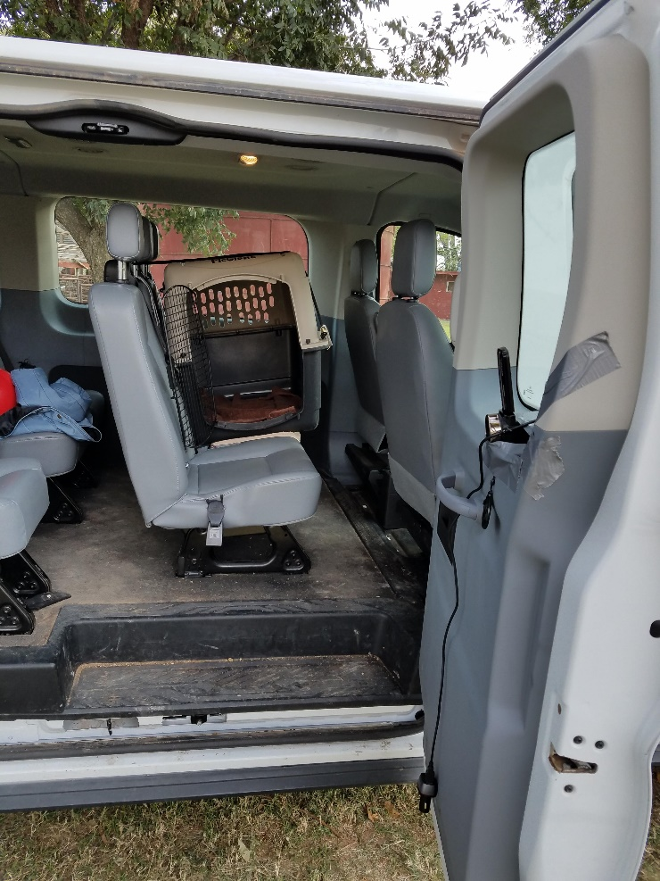
Experimental Design
This study used a parallel design in which dogs were randomly assigned to receive either CON or CALM spray, with eight dogs per treatment, balanced by sex, and then assigned to an appropriately designated vehicle. Dogs were given a ten-minute HR belt acclimation period, and then were walked via leash to the running vans, where they were loaded into the carriers. Once inside the van, treatments were administered by spraying the towel for three consecutive seconds, and then spraying the air in front of the animal for one second. Next, HR and behavior data were collected for ten minutes in the stationary vehicles (“pre” period), followed by the transport period (“drive” period). Upon return to the facility, HR monitors were removed and dogs were returned to their home kennels. Transport carriers were cleaned and a new towel was placed inside the carrier.
Behavior
A video camera (HausBell HDBV-301, USClound Trade Ltd., Rosemead CA. USA) was secured to the door of the van facing the carrier door, such that the entirety of the carrier interior could be viewed. Behaviors of interest were sitting, standing, lying down, moving (postural behaviors), panting, vocalizing, and lip-licking. Videos were viewed at Texas Tech University and behavior was recorded using a one-minute scan sample. At each minute the dog’s postural behavior was recorded as well as whether the dog was panting. Vocalizations and lip-licking were recorded as they occurred.
Heart Rate
Dogs were fitted with a Polar Pro HR monitor (RS800CX, Polar Electro, Lake Success, NY) with ultrasound gel applied to the belts to optimize signal conduction, and belts were fitted snugly around the thorax with the sensor centered on the sternum, just caudal to the forelimb. HR was recorded every one second and averaged over ten minutes for the “pre” period and in five-minute periods during the “drive” period. Outliers in HR data were determined by visual observation of the raw data file, and values below 60 bpm or above 200 bpm as well as those inconsistent with surrounding values were considered erroneous and were removed from the dataset.
Data Analyses
HR monitors failed in two of the eight dogs in the CON group, leaving a sample size of 14 dogs.
HR data were checked for normality using Shapiro-Wilks test (W₁₃₂ = 0.9898, P = 0.2666) in SAS 9.4. First, HR data in the “drive” period were analyzed by five-minute periods compared to the “pre” period using the PROC MIXED procedure of SAS 9.4, with main effects of SEX, TRT, TIME, and interactions of SEX*TRT and TRT*TIME, using DOG(TIME) as the error term. SEX had no effect and so was removed from the model. Next, HR during the “drive” period were compared to basal HR (“basal”) and “pre” period using PROC MIXED, with main effects of TRT, PER, and TRT*PER. Post hoc comparisons were made using Least Squares means where appropriate.
Behavior data were not normally distributed and so were analyzed using the Wilcoxon Signed Rank test to compare number of instances of each behavior between treatments during the study. For ease of understanding, behavior data are presented as percent of time dogs spent engaged in sitting, lying, standing, panting, and moving behavior immediately before and during transport. Vocalizations and lip-licking are presented as the average number of occurrences of each behavior during the study.
Results and Discussion
Heart Rate
When analyzed by time, there were no interactions of TRT*TIME on HR. There was a main effect of TRT, with dogs receiving CALM spray having an average overall HR of 108 bpm, compared to an average overall HR of 132 bpm for dogs receiving the CON spray (F₁₃₂ = 8.03, P < 0.01). There was also a main effect of TIME (F₁₃₂ = 3.01, P = 0.0013). The only remarkable difference between time points occurs as a depression in HR during times 40 and 45, near the end of the driving time.
Although the treatment*time interaction was not significant, Figure 2 illustrates the HR pattern for dogs in both treatment groups before and during transport. As previously shown, dogs receiving TRT spray had an overall lower HR than did dogs receiving CON spray
Figure 2. Average heart rate of dogs receiving either a placebo spray (CON) or Sentry Calming Spray (CALM) before and during ground transport. n = 8 dogs/CON and 6 dogs/CALM.

The average basal HR of ten of the dogs used in this study was known from previous studies, and compared to the “pre” and “drive” periods for these dogs. There was no TRT*PER interaction on HR Again, there was a main effect of TRT (F₂₀ = 4.77, P = 0.04). There was an effect of PER on HR (F₂₀ = 4.19, P = 0.03). The average basal HR of dogs in both treatment groups was 107. HR in the “pre” period and in the “drive” period was higher than the basal period by 17 and 13 bpm, respectively (t₂₀ = -2.81 and -2.24, P = 0.01 and 0.04, respectively). Figure 3 illustrates the average HR of dogs in both treatment groups in each period.

Figure 3. Average basal heart rate (“basal”) and heart rate before (“pre”) and during (“drive”) transport of dogs receiving a placebo spray (CON) or Sentry Calming Spray (CALM). n = 8 dogs/CON and 6 dogs/CALM.
*
*
*Within treatment, Least Squares means differ from “basal” HR, P < 0.05
Behavior
Behavior data are shown in Table 3. Overall there were no differences in sitting, lying, moving, panting, or lip-licking behavior between dogs receiving CON spray and those receiving CALM spray. Dogs receiving CALM spray spent approximately 7.0% of the time standing compared to 16.2% in dogs receiving CON spray (S = -32, P = 0.0020). Dogs in the CON group vocalized an average of 3.0 times during the study; in contrast, dogs in the CALM group vocalized an average of 0.1 times during the study (S = 39, P = 0.0005). Whining was the most common type of vocalization noted, with only two instances of barking observed during the entire study.

Table 3. Average percent of time dogs spent sitting, lying down, standing, moving, or panting, and average number of vocalizations and lip-licks during ground transport when treated with a placebo spray (CON) or Sentry Calming Spray (CALM). n = 8 dogs/CON and 6 dogs/TRT.
Treatment | Sitting (%) | Lying (%) | Standing (%) | Moving (%) | Panting (%) | Vocalizations (#) | Lip-Licks (#)
CON | 37.1 | 42.4 | 7.0 | 13.5 | 19.5 | 3.0 | 5.7
CALM | 37.9 | 36.8 | 16.2 | 9.1 | 18.9 | 0.1 | 5.0
SE | 0.32 | 0.30 | 0.10 | 0.17 | 0.41 | 0.47 | 0.65
P-value | 0.84 | 0.27 | < 0.01 | 0.21 | 0.23 | <0.01 | 0.42
Discussion
The observed elevation of HR in both groups from “basal” indicates that this model of stress in domestic dogs is effective. “Basal” HR was not different between the two treatment groups; however, dogs receiving CALM spray had a lower average heart rate both in the “pre” and “drive” periods. Also interesting is that in dogs receiving CON spray, HR increases from the observed average in the “pre” period during the first five minutes of the “drive” period; in contrast, HR of dogs receiving CALM spray continued to decrease during this period. The results of the present study suggest that Sentry Calming Spray does elicit an effect on HR during ground transport.
In terms of behavior differences, it was anticipated that moving, vocalization, and lip-licking would be reduced in dogs receiving CALM spray. While moving behavior was not significantly different, it was reduced in the CALM group. The average number of lip-licks was very similar between treatment groups. Lip-licking can be interpreted as either a sign of distress (Schwizgebel, 1982) or a sign of nausea (Twedt, 2000), both of which can be attributed to riding in a vehicle. Only two dogs in the CALM group and one dog in the CON group vomited, so nausea could not be accurately statistically assessed in this study. As anticipated, frequency of vocalizations, an indicator of stress in domestic dogs (Beerda et al., 1997) was higher in dogs in the CON group, with whining being the most commonly noted type of vocalization. Most of the vocalizations occurred in two of the eight dogs in the CON group. Interestingly, dogs in the CALM group spent more time standing up during the study compared to the CON group.
One important distinction of dogs in this study is that 11 of the 14 dogs reported in this study have been determined to be experiencing a chronic state of stress as evidenced by results of an adrenocorticotropic hormone (ACTH) stimulation test. Although Cushing’s syndrome, which can result in similarly elevated ACTH stimulation test results (Behrend et al., 2001) was not ruled out, the dogs in this study receive an annual veterinary examination and are generally considered to be in good health. One of the 14 dogs had ACTH stimulation test results within normal levels, and ACTH stimulation test results for two dogs are not available. For dogs existing in a state of chronic stress, the hypothalamic-pituitary-adrenal (HPA) axis operates under a seemingly normal level of activity; however, an acute stressor results in a significantly elevated release of cortisol into the bloodstream. It is possible that this difference in HPA axis function between non-stressed and chronically-stressed dogs may influence the anxiolytic effects of 2-methylbut-2-enal. This relationship should be further investigated in order to determine the most effective use of 2-methylbut-2-enal as a modifier of stress in domestic dogs.
Overall, the results of this study suggest that Sentry Calming Spray, with the active ingredient of 2-methylbut-2-enal, does modify heart rate and behavior of chronically-stressed domestic dogs during transport in a vehicle in a manner consistent with the anticipated anxiolytic effects of the product.
References
Ache BW, Young JM (2005) Olfaction: diverse species, conserved principles. Neuron 48: 471- 430.
Beerda, B., Schilder, M. B., van Hooff, J. A., & de Vries, H. W. (1997). Manifestations of chronic and acute stress in dogs. Applied Animal Behaviour Science, 52(3-4), 307-319.

Behrend, E. N., & Kemppainen, R. J. (2001). Diagnosis of canine hyperadrenocorticism. Veterinary Clinics of North America: Small Animal Practice, 31(5), 985-1003.

Frank, D., Gauthier, A., & Bergeron, R. (2006). Placebo-controlled double-blind clomipramine trial for the treatment of anxiety or fear in beagles during ground transport. The Canadian Veterinary Journal, 47(11), 1102.

Karlson, P., & Lüscher, M. (1959). ‘Pheromones’: a new term for a class of biologically active substances. Nature, 183(4653), 55-56.

Knowles, T. G., Brown, S. N., Warriss, P. D., Phillips, A. J., Dolan, S. K., Hunt, P., ... & Watkins, P. E. (1995). Effects on sheep of transport by road for up to 24 hours. The Veterinary Record, 136(17), 431-438.

Kuhn, G., Lichtwald, K., Hardegg, W., & Abel, H. H. (1990). The effect of transportation stress on circulating corticosteroids, enzyme activities and hematological values in laboratory dogs. Journal of experimental animal science, 34(3), 99-104.

McGlone, J (2011) The Pheromone Site. http://www.depts.ttu.edu/animalwelfare/Research/Pheromones/index.php (accessed 2 June 2015).

Overall, K. L. (1997). Pharmacologic treatments for behavior problems. Veterinary Clinics of North America: Small Animal Practice, 27(3), 637-665.

Schaal, B., Coureaud, G., Langlois, D., Giniès, C., Sémon, E., & Perrier, G. (2003). Chemical and behavioural characterization of the rabbit mammary pheromone. Nature, 424(6944), 68-72.

Schwizgebel, D. (1982). Zusammenhänge zwischen dem Verhalten des Tierlehrers und dem Verhalten des Deutschen Schäferhundes im Hinblick auf tiergerechte Ausbildung. Aktuelle Arbeiten zur artgemassen Tierhaltung, 138-148.
Twedt DC (2000) Vomiting. In: Textbook of Veterinary Internal Medicine Vol. 1 (5th edn). Ettinger SJ, Feldman EC (eds). WB Saunders Co., Philadelphia, PA, USA. pp. 117–121.

